**Assignment -3**

**Abalone Age Prediction**

|  |  |
| --- | --- |
| Assignment Date | 10october2022 |
| Student Name | DHILIP KUMAR P |
| Student Roll Number | 820419104018 |
| Maximum Marks | 2 Marks |

**1.Importing necessary packages & Downloading the packages**

Solution:

**import** pandas **as** pd

**from** sklearn.model_selection **import** train_test_split

**import** matplotlib.pyplot **as** plt

**import** seaborn **as** sns

**from** sklearn.preprocessing **import** StandardScaler

**from** sklearn.preprocessing **import** LabelEncoder

**import** numpy **as** np

**from** collections **import** Counter

**from** sklearn.pipeline **import** make_pipeline

**from** sklearn.linear_model **import** Ridge, Lasso

**from** sklearn.ensemble **import** RandomForestRegressor

**from** sklearn.pipeline **import** make_pipeline

**from** sklearn.linear_model **import** Ridge, Lasso

**from** sklearn.model_selection **import** GridSearchCV

**from** sklearn.exceptions **import** NotFittedError

**from** sklearn.metrics **import** r2_score,mean_absolute_error

**2. Download the dataset**

Solution:

df**=** pd**.**read_csv("abalone.csv")

df**.**head()

Output:

|  | **Sex** | **Length** | **Diameter** | **Height** | **Whole weight** | **Shucked weight** | **Viscera weight** | **Shell weight** | **Rings** |
| --- | --- | --- | --- | --- | --- | --- | --- | --- | --- |
| **0** | M | 0.455 | 0.365 | 0.095 | 0.5140 | 0.2245 | 0.1010 | 0.150 | 15 |
| **1** | M | 0.350 | 0.265 | 0.090 | 0.2255 | 0.0995 | 0.0485 | 0.070 | 7 |
| **2** | F | 0.530 | 0.420 | 0.135 | 0.6770 | 0.2565 | 0.1415 | 0.210 | 9 |
| **3** | M | 0.440 | 0.365 | 0.125 | 0.5160 | 0.2155 | 0.1140 | 0.155 | 10 |
| **4** | I | 0.330 | 0.255 | 0.080 | 0.2050 | 0.0895 | 0.0395 | 0.055 | 7 |

**3. Visualizations**

**(i) Univariate Analysis**

Solution:

sns**.**displot(df["Diameter"])

Output:

<seaborn.axisgrid.FacetGrid at 0x1a7c3cc60a0>

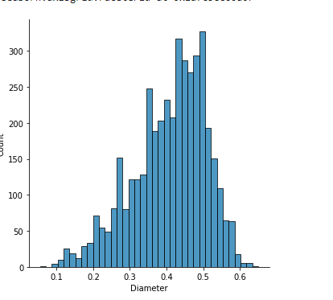

Solution:

sns**.**set(rc**=**{'figure.figsize':(7,7)})

depth **=** df['Rings']**.**value_counts(normalize**=False**)**.**reset_index()

sns**.**barplot(data**=**depth,x**=**'index',y**=**'Rings')

Output:

<AxesSubplot:xlabel='index', ylabel='Rings'>

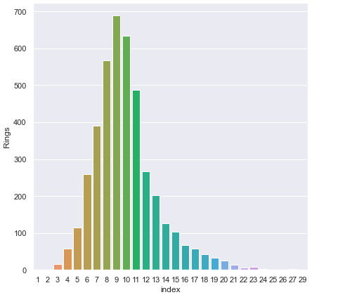

Solution:

df['Sex']**.**value_counts()**.**plot(kind**=**'pie',autopct**=**'%.0f')

Output:

<AxesSubplot:ylabel='Sex'>

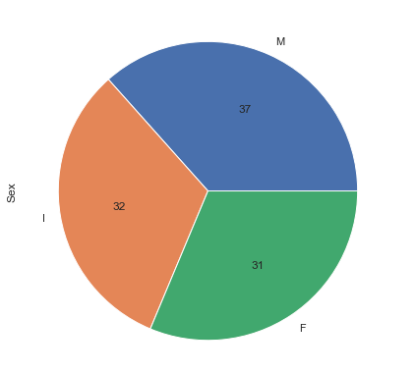

**(ii) BiVariate Analysis**

Solution:

sns**.**set(rc**=**{'figure.figsize':(17,10)})

sns**.**countplot(df['Rings'] ,hue **=** df['Sex'] ,color **=**'y')

<AxesSubplot:xlabel='Rings', ylabel='count'>

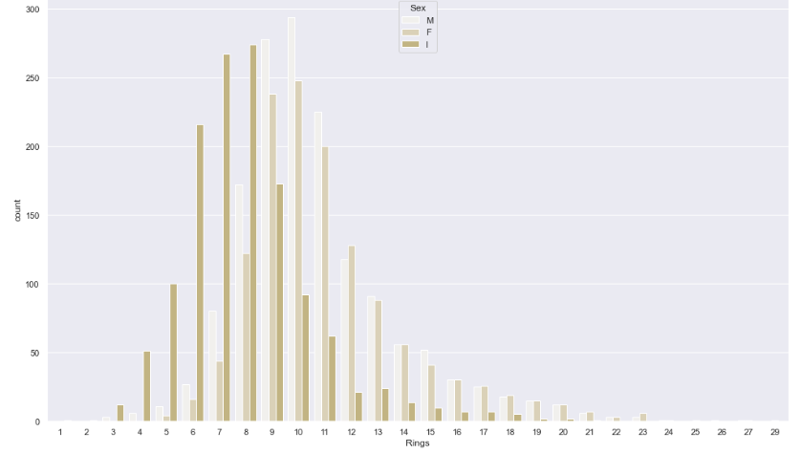

Solution:

sns**.**set(rc**=**{'figure.figsize':(10,7)})

plt**.**scatter(df**.**Length, df**.**Height)

plt**.**title('Length vs Height')

plt**.**xlabel('Height')

plt**.**ylabel('Length')

Output:

Text(0, 0.5, 'Length')

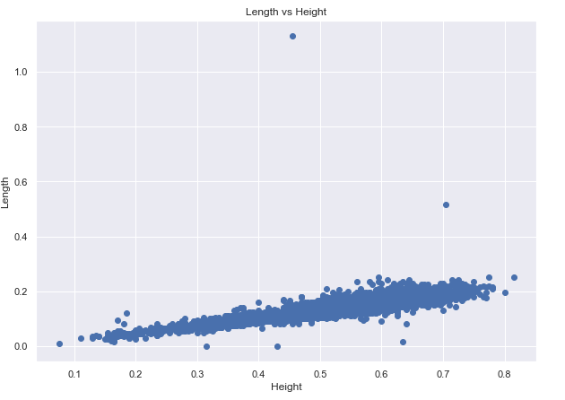

**(iii) MultiVariate Analysis**

Solution:

plt**.**figure(figsize**=**(12,10))

sns**.**pairplot(df)

Output:

<seaborn.axisgrid.PairGrid at 0x1a8005d43a0>

<Figure size 864x720 with 0 Axes>

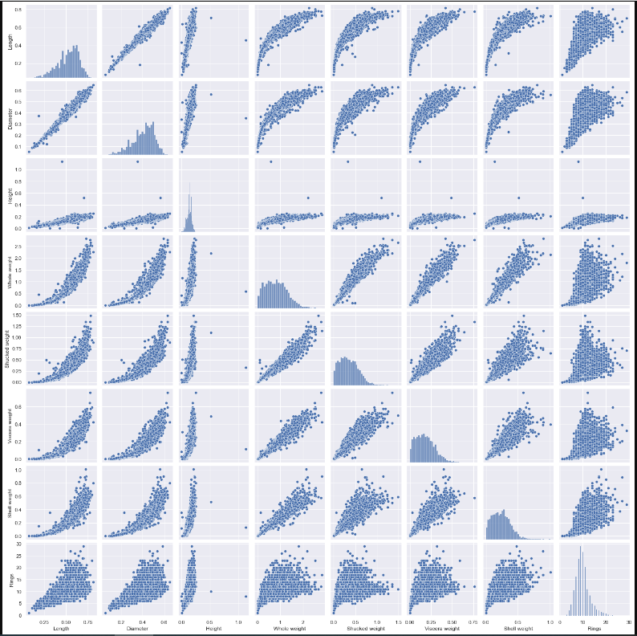

Solution:

plt**.**figure(figsize **=** (8,6))

corr **=** df**.**corr()

sns**.**heatmap(corr, annot **=** **True**)

Output:

<AxesSubplot:>

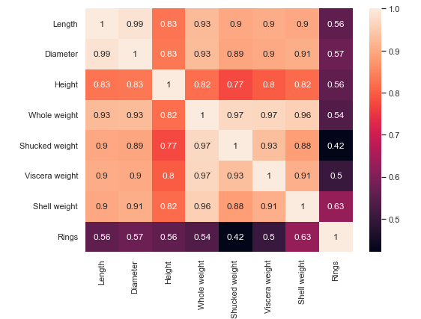

**4.Descriptive Statistics**

Solution:

df**.**info()

<class 'pandas.core.frame.DataFrame'>

RangeIndex: 4177 entries, 0 to 4176

Data columns (total 9 columns):

# Column Non-Null Count Dtype

--- ------ -------------- -----

0 Sex 4177 non-null object

1 Length 4177 non-null float64

2 Diameter 4177 non-null float64

3 Height 4177 non-null float64

4 Whole weight 4177 non-null float64

5 Shucked weight 4177 non-null float64

6 Viscera weight 4177 non-null float64

7 Shell weight 4177 non-null float64

8 Rings 4177 non-null int64

dtypes: float64(7), int64(1), object(1)

memory usage: 293.8+ KB

Solution:

df**.**describe()

Output:

|  | **Length** | **Diameter** | **Height** | **Whole weight** | **Shucked weight** | **Viscera weight** | **Shell weight** | **Rings** |
| --- | --- | --- | --- | --- | --- | --- | --- | --- |
| **count** | 4177.000000 | 4177.000000 | 4177.000000 | 4177.000000 | 4177.000000 | 4177.000000 | 4177.000000 | 4177.000000 |
| **mean** | 0.523992 | 0.407881 | 0.139516 | 0.828742 | 0.359367 | 0.180594 | 0.238831 | 9.933684 |
| **std** | 0.120093 | 0.099240 | 0.041827 | 0.490389 | 0.221963 | 0.109614 | 0.139203 | 3.224169 |
| **min** | 0.075000 | 0.055000 | 0.000000 | 0.002000 | 0.001000 | 0.000500 | 0.001500 | 1.000000 |
| **25%** | 0.450000 | 0.350000 | 0.115000 | 0.441500 | 0.186000 | 0.093500 | 0.130000 | 8.000000 |
| **50%** | 0.545000 | 0.425000 | 0.140000 | 0.799500 | 0.336000 | 0.171000 | 0.234000 | 9.000000 |
| **75%** | 0.615000 | 0.480000 | 0.165000 | 1.153000 | 0.502000 | 0.253000 | 0.329000 | 11.000000 |
| **max** | 0.815000 | 0.650000 | 1.130000 | 2.825500 | 1.488000 | 0.760000 | 1.005000 | 29.000000 |

**5.Handle Missing Values**

Solution:

df**.**isna()**.**sum()

Output:

Sex 0

Length 0

Diameter 0

Height 0

Whole weight 0

Shucked weight 0

Viscera weight 0

Shell weight 0

Rings 0

dtype: int64

**6. Outlier Detection**

Solution:

outlier_correction_df **=** df**.**drop(columns**=**['Sex'],axis**=**1)

outlier_correction_df**.**head()

Output:

|  | **Length** | **Diameter** | **Height** | **Whole weight** | **Shucked weight** | **Viscera weight** | **Shell weight** | **Rings** |
| --- | --- | --- | --- | --- | --- | --- | --- | --- |
| **0** | 0.455 | 0.365 | 0.095 | 0.5140 | 0.2245 | 0.1010 | 0.150 | 15 |
| **1** | 0.350 | 0.265 | 0.090 | 0.2255 | 0.0995 | 0.0485 | 0.070 | 7 |
| **2** | 0.530 | 0.420 | 0.135 | 0.6770 | 0.2565 | 0.1415 | 0.210 | 9 |
| **3** | 0.440 | 0.365 | 0.125 | 0.5160 | 0.2155 | 0.1140 | 0.155 | 10 |
| **4** | 0.330 | 0.255 | 0.080 | 0.2050 | 0.0895 | 0.0395 | 0.055 | 7 |

Solution:

**def** detection(df,features):

outlier_indices**=**[]

**for** c **in** features:

Q1 **=** np**.**percentile(df[c],25)

Q3 **=** np**.**percentile(df[c],75)

IQR **=** Q3 **-** Q1

outlier_step **=** IQR **\*** 1.5

lower_range **=** Q1 **-** (outlier_step)

upper_range **=** Q3 **+** (outlier_step)

outlier_list_col**=**df[ (df[c] **<** lower_range) **|** (df[c] **>** upper_range) ]**.**index

outlier_indices**.**extend(outlier_list_col)

**return** outlier_indices

**def** multiple_outlier_indices(outlier_indices):

outlier_indices**=**Counter(outlier_indices)

multiple_outliers **=** list(i **for** i, v **in** outlier_indices**.**items() **if** v **>** 2 )

**return** multiple_outliers

Solution:

outlier_correction_df**.**columns

Output:

Index(['Length', 'Diameter', 'Height', 'Whole weight', 'Shucked weight',

'Viscera weight', 'Shell weight', 'Rings'],

dtype='object')

Solution:

outliers**=**detection(df,['Length', 'Diameter', 'Height', 'Whole weight', 'Shucked weight',

'Viscera weight', 'Shell weight'])

Solution:

Counter(outliers)

Output:

Counter({148: 2,

149: 2,

236: 3,

237: 3,

238: 3,

239: 3,

305: 2,

306: 3,

321: 2,

465: 2,

523: 2,

525: 2,

526: 2,

611: 2,

694: 3,

696: 2,

718: 3,

719: 3,

720: 3,

1053: 2,

1054: 2,

1055: 2,

1056: 1,

1210: 1,

1429: 3,

1824: 2,

1986: 2,

1987: 3,

2114: 3,

2115: 2,

2169: 3,

2171: 3,

2343: 2,

2371: 2,

2380: 2,

2381: 3,

2458: 2,

2711: 3,

3141: 2,

3143: 2,

3190: 3,

3318: 2,

3380: 2,

3472: 2,

3600: 2,

3837: 3,

3899: 3,

3902: 3,

3994: 2,

43: 1,

44: 1,

520: 1,

892: 1,

898: 1,

1988: 1,

2172: 2,

2545: 1,

2712: 1,

3473: 1,

3521: 1,

3716: 1,

1174: 1,

1257: 1,

1417: 2,

1428: 3,

1763: 4,

2051: 1,

2179: 1,

3996: 1,

165: 3,

358: 2,

891: 3,

1051: 2,

1052: 3,

1193: 3,

1206: 3,

1207: 4,

1209: 3,

1426: 2,

1427: 3,

1761: 3,

1762: 4,

2265: 1,

2334: 2,

2623: 3,

2624: 3,

2811: 3,

2862: 2,

2863: 3,

3007: 2,

3008: 2,

3188: 2,

3427: 3,

3599: 2,

3715: 4,

3800: 1,

3993: 2,

1048: 2,

1197: 1,

1199: 1,

1202: 1,

1418: 1,

1527: 1,

1528: 1,

1749: 1,

1750: 2,

1754: 1,

1756: 1,

1821: 1,

1982: 1,

2544: 1,

2625: 1,

2675: 1,

2710: 2,

2810: 2,

2970: 1,

2972: 1,

3082: 1,

3713: 1,

3961: 1,

3962: 1,

170: 1,

1204: 1,

1422: 1,

1757: 1,

1759: 1,

2709: 1,

3628: 1,

4148: 1,

81: 1,

129: 1,

157: 1,

163: 1,

164: 1,

166: 1,

167: 1,

168: 1,

277: 1,

334: 1,

1823: 1,

1985: 1,

2090: 1,

2108: 1,

2157: 1,

2161: 1,

2208: 1,

2274: 1,

2368: 1,

3148: 1,

3149: 1,

3151: 1,

3928: 1,

4145: 1})

Solution:

multiple_outlier_indices **=** multiple_outlier_indices(outliers)

Solution:

print(Counter(multiple_outlier_indices))

Counter({236: 1, 237: 1, 238: 1, 239: 1, 306: 1, 694: 1, 718: 1, 719: 1, 720: 1, 1429: 1, 1987: 1, 2114: 1, 2169: 1, 2171: 1, 2381: 1, 2711: 1, 3190: 1, 3837: 1, 3899: 1, 3902: 1, 1428: 1, 1763: 1, 165: 1, 891: 1, 1052: 1, 1193: 1, 1206: 1, 1207: 1, 1209: 1, 1427: 1, 1761: 1, 1762: 1, 2623: 1, 2624: 1, 2811: 1, 2863: 1, 3427: 1, 3715: 1})

Solution:

df**=**df**.**drop(multiple_outlier_indices,axis**=**0)**.**reset_index(drop **=** **True**)

df

Output:

|  | **Sex** | **Length** | **Diameter** | **Height** | **Whole weight** | **Shucked weight** | **Viscera weight** | **Shell weight** | **Rings** |
| --- | --- | --- | --- | --- | --- | --- | --- | --- | --- |
| **0** | M | 0.455 | 0.365 | 0.095 | 0.5140 | 0.2245 | 0.1010 | 0.1500 | 15 |
| **1** | M | 0.350 | 0.265 | 0.090 | 0.2255 | 0.0995 | 0.0485 | 0.0700 | 7 |
| **2** | F | 0.530 | 0.420 | 0.135 | 0.6770 | 0.2565 | 0.1415 | 0.2100 | 9 |
| **3** | M | 0.440 | 0.365 | 0.125 | 0.5160 | 0.2155 | 0.1140 | 0.1550 | 10 |
| **4** | I | 0.330 | 0.255 | 0.080 | 0.2050 | 0.0895 | 0.0395 | 0.0550 | 7 |
| **...** | ... | ... | ... | ... | ... | ... | ... | ... | ... |
| **4134** | F | 0.565 | 0.450 | 0.165 | 0.8870 | 0.3700 | 0.2390 | 0.2490 | 11 |
| **4135** | M | 0.590 | 0.440 | 0.135 | 0.9660 | 0.4390 | 0.2145 | 0.2605 | 10 |
| **4136** | M | 0.600 | 0.475 | 0.205 | 1.1760 | 0.5255 | 0.2875 | 0.3080 | 9 |
| **4137** | F | 0.625 | 0.485 | 0.150 | 1.0945 | 0.5310 | 0.2610 | 0.2960 | 10 |
| **4138** | M | 0.710 | 0.555 | 0.195 | 1.9485 | 0.9455 | 0.3765 | 0.4950 | 12 |

4139 rows × 9 columns

Solution:

df**.**shape

Output:

(4139, 9)

**7. Categorical Attribute Encoding**

Solution:

le**=**LabelEncoder()

df['Sex']**=**le**.**fit_transform(df['Sex'])

Solution:

df**.**head()

Output:

|  | **Sex** | **Length** | **Diameter** | **Height** | **Whole weight** | **Shucked weight** | **Viscera weight** | **Shell weight** | **Rings** |
| --- | --- | --- | --- | --- | --- | --- | --- | --- | --- |
| **0** | 2 | 0.455 | 0.365 | 0.095 | 0.5140 | 0.2245 | 0.1010 | 0.150 | 15 |
| **1** | 2 | 0.350 | 0.265 | 0.090 | 0.2255 | 0.0995 | 0.0485 | 0.070 | 7 |
| **2** | 0 | 0.530 | 0.420 | 0.135 | 0.6770 | 0.2565 | 0.1415 | 0.210 | 9 |
| **3** | 2 | 0.440 | 0.365 | 0.125 | 0.5160 | 0.2155 | 0.1140 | 0.155 | 10 |
| **4** | 1 | 0.330 | 0.255 | 0.080 | 0.2050 | 0.0895 | 0.0395 | 0.055 | 7 |

**8. Seperate dataframe into Predictor and Target**

Solution:

feature **=**pd**.**DataFrame(df**.**drop(['Rings'], axis **=** 1))

label **=** pd**.**DataFrame(df**.**Rings)

**9. Scaling the Predictor variables**

Solution:

convert **=** StandardScaler()

feature **=** pd**.**DataFrame(convert**.**fit_transform(feature))

**10. Perform the train test split**

Solution:

X_train, X_test, y_train, y_test **=** train_test_split(feature, label, test_size **=** 0.2, random_state **=** 0)

Solution:

print('X_train : ')

print(X_train)

print(X_train**.**shape)

print('')

print('X_test : ')

print(X_test)

print(X_test**.**shape)

print('')

print('y_train : ')

print(y_train)

print(y_train**.**shape)

print('')

print('y_test : ')

print(y_test)

print(y_test**.**shape)

X_train :

0 1 2 3 4 5 6 \

64 1.151942 -0.040971 -0.087769 -0.481759 -0.514480 -0.574405 -0.453057

1521 -0.062807 -1.409929 -1.432469 -1.091508 -1.310493 -1.322352 -1.158735

3436 1.151942 1.670227 1.618965 1.469438 2.013909 1.674082 1.916340

3444 -0.062807 -0.768230 -0.760119 -0.725659 -0.868496 -0.720742 -0.798886

3993 -0.062807 -0.725450 -0.863557 -0.725659 -0.689393 -0.462910 -0.565218

... ... ... ... ... ... ... ...

1033 1.151942 1.413547 1.205212 0.859689 1.832711 2.173488 1.701365

3264 1.151942 1.028527 0.946616 1.225538 0.845026 0.772829 0.916240

1653 -1.277555 0.729068 0.688019 0.493839 0.607270 0.120118 0.402169

2607 -0.062807 -0.725450 -0.708400 -0.969558 -0.876875 -0.690546 -0.995167

2732 -0.062807 0.215709 0.119108 0.371889 0.180984 0.638106 0.004933

7

64 -0.390700

1521 -1.300351

3436 2.132846

3444 -1.014251

3993 -0.959232

... ...

1033 1.223195

3264 1.149837

1653 1.032462

2607 -0.992243

2732 -0.243983

[3311 rows x 8 columns]

(3311, 8)

X_test :

0 1 2 3 4 5 6 \

958 1.151942 -0.126531 0.015669 0.127990 -0.062009 0.134054 0.014280

2613 -0.062807 -0.425991 -0.346365 -0.603709 -0.639119 -0.579050 -0.569891

45 -0.062807 -1.153250 -1.173873 -1.091508 -1.304208 -1.254990 -1.261549

3145 -1.277555 -0.169311 0.015669 -0.115910 -0.353182 -0.309604 -0.439037

3994 -0.062807 -0.340431 -0.449804 -1.213458 -0.365751 -0.191140 -0.448384

... ... ... ... ... ... ... ...

620 -1.277555 -0.853790 -0.760119 -1.091508 -1.054931 -1.101684 -1.112002

1544 -0.062807 -0.597110 -0.501523 -0.603709 -0.772137 -0.692869 -0.883007

2954 1.151942 0.087369 -0.036050 0.859689 0.931959 0.884324 1.369556

177 -0.062807 -2.564988 -2.570292 -2.311006 -1.632040 -1.545343 -1.541951

50 -0.062807 -0.040971 0.015669 -0.481759 -0.483058 -0.553499 -0.644665

7

958 -0.313674

2613 -0.680468

45 -1.197648

3145 -0.317342

3994 -0.427380

... ...

620 -0.830854

1544 -0.669464

2954 0.724355

177 -1.637802

50 -0.354021

[828 rows x 8 columns]

(828, 8)

y_train :

Rings

64 8

1521 8

3436 11

3444 7

3993 8

... ...

1033 8

3264 17

1653 10

2607 7

2732 9

[3311 rows x 1 columns]

(3311, 1)

y_test :

Rings

958 8

2613 7

45 7

3145 15

3994 8

... ...

620 10

1544 10

2954 13

177 4

50 8

[828 rows x 1 columns]

(828, 1)

**11.Build Model**

Solution:

pipelines**=**{

'rf':make_pipeline(RandomForestRegressor(random_state**=**1234)),

'ridge':make_pipeline(Ridge(random_state**=**1234)),

'lasso':make_pipeline(Lasso(random_state**=**1234)),

}

Solution:

hyperparagrid**=**{

'rf':{

'randomforestregressor__min_samples_split':[2,4,6],

'randomforestregressor__min_samples_leaf':[1,2,3]

},

'ridge':{

'ridge__alpha':[0.001,0.005,0.01,0.05,0.1,0.5,0.99]

},

'lasso':{

'lasso__alpha':[0.001,0.005,0.01,0.05,0.1,0.5,0.99]

}

}

**12. Traning the Model**

Solution:

fit_models**=**{}

**for** algo,pipeline **in** pipelines**.**items():

model**=**GridSearchCV(pipeline,hyperparagrid[algo],cv**=**10,n_jobs**=-**1)

**try**:

print('Start training for {}'**.**format(algo))

model**.**fit(X_train,y_train)

fit_models[algo]**=**model

**except** NotFittedError **as** e:

print(repr(e))

Start training for rf

Start training for ridge

Start training for lasso

**13,14 Testing and Measuring Performance**

Solution:

best_model_rf**=**fit_models['rf']

best_model_rf

Output:

GridSearchCV(cv=10,

estimator=Pipeline(steps=[('randomforestregressor',

RandomForestRegressor(random_state=1234))]),

n_jobs=-1,

param_grid={'randomforestregressor__min_samples_leaf': [1, 2, 3],

'randomforestregressor__min_samples_split': [2, 4, 6]})

Solution:

best_model_ridge**=**fit_models['ridge']

best_model_ridge

Output:

GridSearchCV(cv=10,

estimator=Pipeline(steps=[('ridge', Ridge(random_state=1234))]),

n_jobs=-1,

param_grid={'ridge__alpha': [0.001, 0.005, 0.01, 0.05, 0.1, 0.5,

0.99]})

Solution:

best_model_lasso**=**fit_models['lasso']

best_model_lasso

Output:

GridSearchCV(cv=10,

estimator=Pipeline(steps=[('lasso', Lasso(random_state=1234))]),

n_jobs=-1,

param_grid={'lasso__alpha': [0.001, 0.005, 0.01, 0.05, 0.1, 0.5,

0.99]})

Solution:

**for** algo,model **in** fit_models**.**items():

ya**=**model**.**predict(X_test)

print('{} scores-R2:{} MAE:{}'**.**format(algo,r2_score(y_test,ya), mean_absolute_error(y_test,ya)))

rf scores-R2:0.5255029479701915 MAE:1.570513566816263

ridge scores-R2:0.5189099860811324 MAE:1.6528099660919895

lasso scores-R2:0.5190720174119673 MAE:1.6525494856846143